# 

# JOURNEY

# TO THE SPIRIT WORLD 2.5D PUZZLE PLATFORMER

The first presented concept is the ‘Journey to the Spirit World’. It’s a 2.5D puzzle platformer that capitalises on the advantage of having two illustrative 2D artists on the team. By having a forced directional perspective, we can arrange a variety of assets both 2D and 3D in the same environment to create a storybook or vintage animation aesthetic.

The narrative centres around a child protagonist who resides in a village with a tradition of honouring spirits on a day that the two worlds are closest, who is tasked with delivering a basket of offerings to the large tree on the top of the hill, On her journey she slips from one world to the other and is faced with a series of puzzles.

Deriving inspiration from Dia de las Muertos, traditional Japanese festivals, Scandinavian folk attire, the mythology of Dusk being a transitional time, a populated fantasy landscape alike the Spirit World in *Avatar: the Last Airbender* and *Avatar: the Legend of Korra*, use of light and aesthetic reminiscent of *Ori and the Blind Forest*.

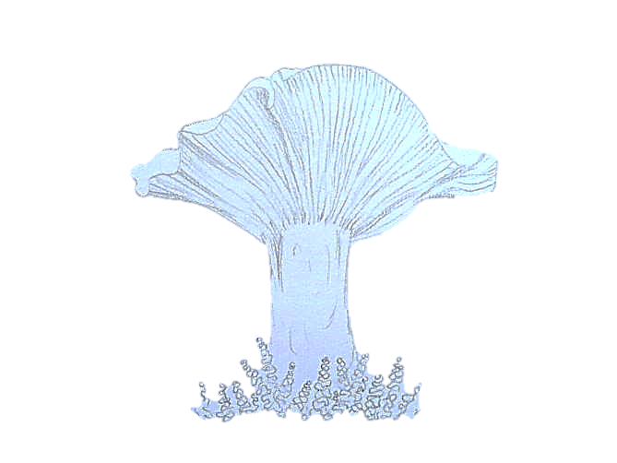The game would give a walking-sim feel at first, however as the character delves deeper into the spirit world, the fantasy elements would create unique challenges; such a giant mushroom platforms, or sneaking past malevolent spirits. And would resolve when the player reaches the tree and has a tea party with the spirits.

It’s a whimsical narrative with a younger target market, and a high saturation of art assets and the gradual environment change would create high replayability.

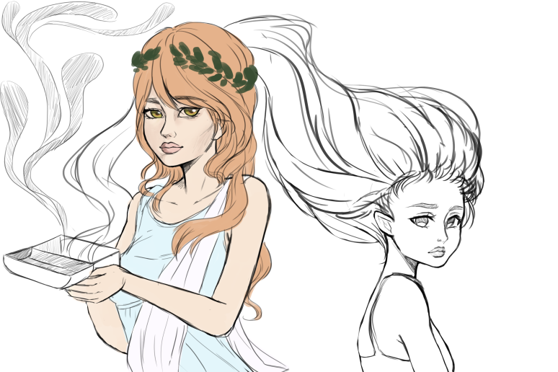

**PANDORA’S**

**BOX  
WALKING SIM**

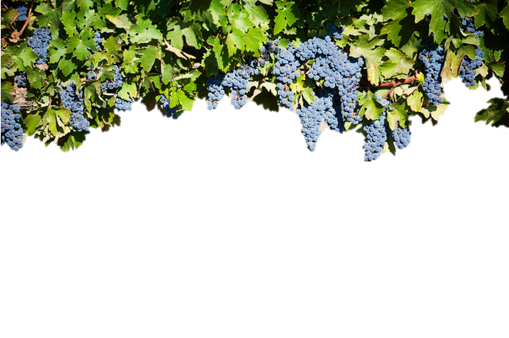

Our second proposal is a walking-sim narrative experience that tells the story of Pandora. The player role plays as Pandora in the house she lives with Epimetheus, it’s a beautiful traditional Ancient Greek building furnished with luxury, the rear arbour overlooking rolling hills. The game has only one executable objective; when the player approaches the box, on a pedestal in its own room, it will present with two options; ‘Open’ and ‘Leave’.

This forces the player to open the box to proceed, which will trigger a brief cinematic, then change the scene to the same house full of all the atrocities she let loose on the world.

The atrocities would include Famine, War, and Scorn. each an animated feature asset with an interaction. Once the player has interacted with all three atrocities it will trigger Hope to spawn in the box room, and the player would be directed back there by a firefly-like particle trail. Hope’s interaction is the game’s final interaction and concludes the narrative.

The game would give each artist a unique feature asset and the architecture would have lots of reusable assets and tiled textures, which increase efficiency.

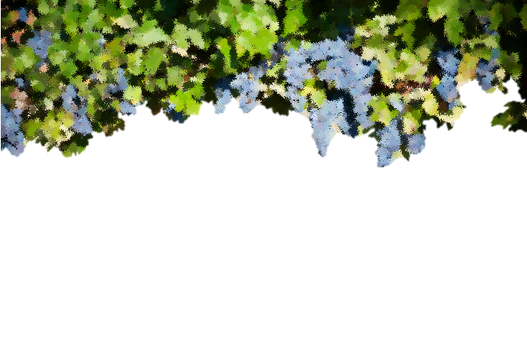

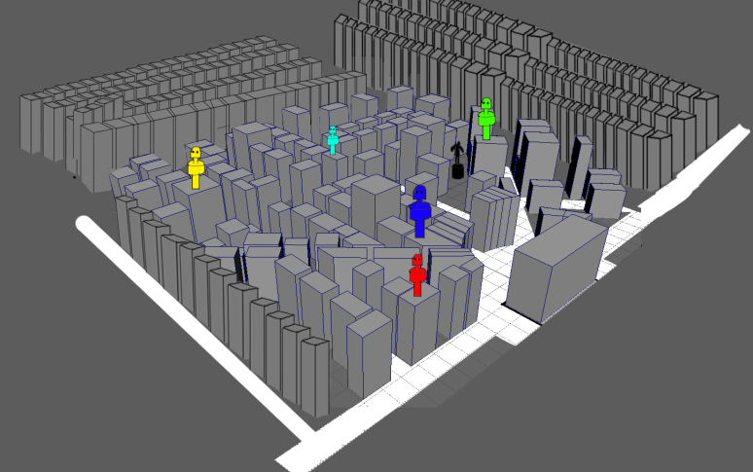

**1940’S UFO ATTACK WITH ROBOTS  
TOWER DEFENSE**

Our third concept is a tower defense game set in a 1940’s town where UFOs attack. Players manage resources to build giant robots who dance around the map to swing music, shooting down UFOs.

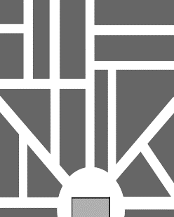

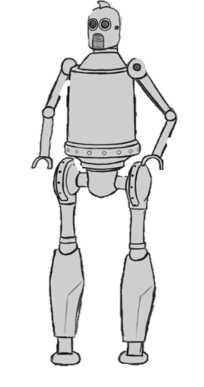The game would have a simulated greyscale aesthetic, so the assets would be painted in colour and then desaturated to ~5% colour, so that it appears greyscale at first, and the colouration will become more obvious as the player keeps looking at it.

It will be a 3D isometric view, limiting the colour scheme and having a strong theme can detract from the art style, so the 3D isometric view with camera rotation will mean that we can place more assets in game. Each artist will have a feature robot with its own unique design, size, speed, and combat abilities. The idea is to use an inward glow shader with a slight colour splash and use that shader for the electronic parts of that robot, as an on-screen identifier.

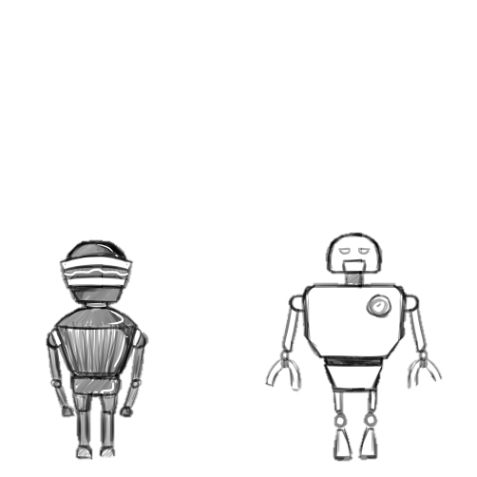The game would be one continuous level that gradually scales in difficulty, which provides over five minutes of gameplay and replayability.